

10/1/2020

**CAMPAIGN LANDING PAGE PLAYBOOK**

Chapter 1: The Background and Purpose of This Work 3

Chapter 2: What Trinity Health Did 3

Chapter 3: Campaign Best Practices 4

Chapter 4: Create a Campaign in CRM Using Campaign Wizard 6

Chapter 5: Creating Marketing Asset(s) 12

Chapter 6: Creating the First Campaign Tactic in a New Campaign 14

Chapter 7: Adding Additional Campaign Tactics to Existing Campaigns 18

Chapter 8: Creating Web Forms in CRM 22

Chapter 9: Forms in Formstack 23

Chapter 10: Syncing Forms to CRM 27

Chapter 11: Campaign Landing Page Set Up 30

Chapter 12: Placing Pixels 37

APPENDIX 39

Appendix A: Trinity Health Campaign Team 40

Appendix B: Template Links 40

Appendix C: Campaign Landing Page Testing Results 41

Appendix D: End-to-End Data Flow 42

# Chapter 1: The Background and Purpose of This Work

Trinity Health engaged in this project to develop a solution that creates RHM campaign landing page consistency and standardization across the enterprise. Creating one consistent look and feel along with standard web forms from which the HMs can choose directly contributes to saving costs, time, and effort and will provide consistency across HMs during their campaigns.

Historically, teams used a hybrid approach: some HMs building their own landing pages, others relying on vendor partners. Healthgrades (f.k.a. Evariant), Trilliant, and other vendor currently have built and optimized most of Trinity Health’s digital campaign landing pages and web forms. As we move toward an ecosystem of less reliance on vendors, Trinity Health teams need to feel empowered to develop campaign landing pages without involvement from third-parties.

**Campaign Landing Page Costs & Savings**

The average campaign landing page and form developed by vendors costs ≈ $5,500. Average campaigns have 2 – 3 landing pages (one for each CTA). In FY19, Trinity Health built approximately 42 campaigns with vendors costing a total of ≈ $126,000. In Q4 of FY20 alone, Trinity Health was able to save ≈ $93,000 using campaign landing page templates.

# Chapter 2: What Trinity Health Did

Trinity Health engaged vendor partners, Perficient and Healthgrades, to wireframe, design, and implement the campaign landing page templates.

**Discovery:**  
Teams evaluated existing campaign landing pages and researched current campaign best practices across the healthcare industry (see chapter 3). This established a framework for developing the new templates. In order to determine which layouts should be comped, the team conducted a thorough inventory of the current campaign pages and use cases for those pages to identify which types of layouts existed and which should comprise the library of six (6) template options for final implementation.

**Look & Feel:**  
Two (2) uniquely designed comps were developed based on the most complex landing pages needed – this included four (4) screens total to include views for both desktop and mobile. The goal of the visual work was to offer a couple of unique applications for users to consider during testing.

Comps for three (3) templates including two (2) layout variations for each (six [6] total comps, 16 clickable screens including both desktop and mobile views) underwent one round of testing to determine consumers’ preferred look and feel.

After initial testing, comps were revised based on consumer feedback and narrowed down to (four [4] layouts total, eight [8] screens including desktop and mobile views) for second round of testing to determine consumers’ preferred look and feel.

Results of the second round of testing were used as direction to create the two (2) final layouts to complete the six (6) total templates for HMs to utilize.

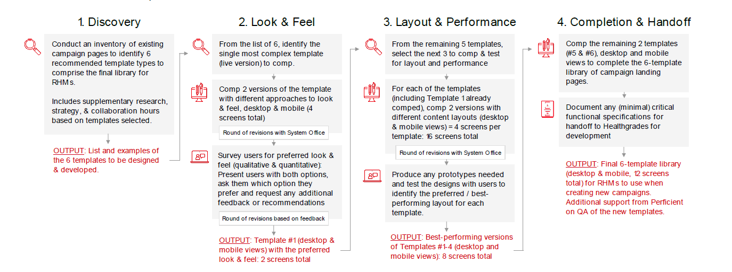

Landing pages were implemented into each HM’s web instance with configurable CSS class names to allow for HM specific brand colors to be assigned.

# Chapter 3: Campaign Best Practices

**Landing Page Best Practices**

1. Design elements employed to drive ROI and CTA responses:
   1. CTA big and positioned above the fold
   2. Directional cues to bring attention to CTA – arrows, images that point to CTA
   3. Landing page should be single minded, one focus per landing page
   4. Every element should focus conceptually on the CTA
   5. Real testimonials for authenticity
2. Look and feel of campaign landing pages should be in brand family:
   1. Should echo the landing page design, remove site links and navigation
   2. Echo site design with graphics, general look and feel, or color scheme and font
   3. Brand identification: Consumers should be able to identify your brand from the campaign landing page. This will assure them that they’re giving their information to a trust/familiar entity.
3. Types of photography to use:
   1. For headline banners: Lifestyle photos, actual patient images are primary
   2. Medical images good for secondary images
4. Use of video content:
   1. Video is great for conversion – for ads and for landing pages
5. Writing style for content:
   1. Headlines should match paid advertisements, want visitors to find the information they were promised
   2. Simplify copy with bullets when possible

**Web Form Best Practices**

1. Fields should be specific to the call-to-action
2. Reduce number of fields and indicate whether each field is required or optional, unless they’re all required
   1. 5 fields or fewer is recommended
   2. Only use required fields for CRM matching or communication purposes
3. Recommended form fields: first name, last name, email, zip code and birthdate  
   Note: Not using the recommended form fields lessens match rate, may result in bad data, and has the propensity to impact ROI reporting
4. Include a privacy message or link within the form box and in the footer of the page
5. Call-to-action buttons for forms should be visible and clear what action is needed

**Go To Market Best Practices**

1. Set up a Successful Landing Page
   1. Easy to Navigate with Clear Direction
   2. Patient centric
   3. CTA is prominent and clear
   4. Clean-cut, minimal wording
   5. Web form placement should be ‘obvious’
   6. Phone number above the fold
   7. Leverage Video content to tell the story
   8. Use lifestyle imagery
2. Define a Successful Call-to-Action
   1. Quickly set the expectation with the user to guide them through a defined process.
   2. Should match the users’ intent based on the complexity/nature of the ailment, disease, etc
   3. A/B test soft and hard calls-to-action
   4. Call-to-action wording should be consistent between ads and landing page
3. Define a Successful Media Mix
   1. Build audience pool with geo-targeted display-prospecting flights
   2. Drive awareness with video
   3. Target specific audience segments with data-targeting display
   4. Nurture and engage with social
   5. Remarket to an already engaged audience with retargeted display
   6. Close with audience with search-intent based mediums that allow users to self-qualify

# Chapter 4: Create a Campaign in CRM Using Campaign Wizard

1. Create campaign (Note: tactics go to child if there is a parent) by clicking on Campaigns Tab then click on New to enter campaign wizard

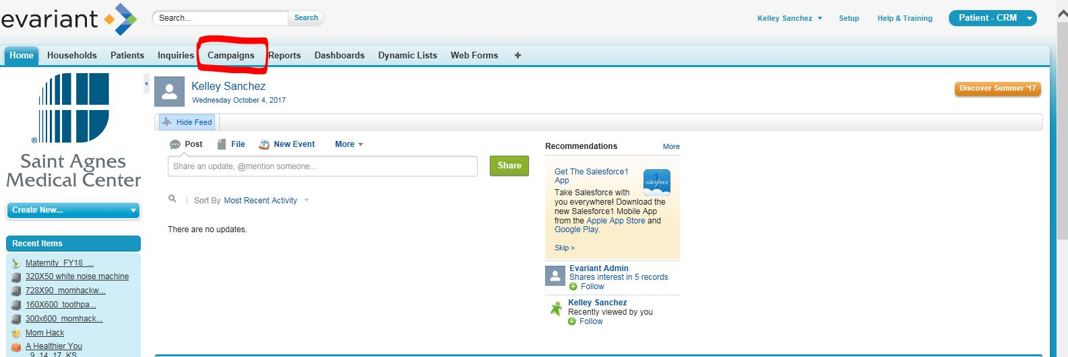

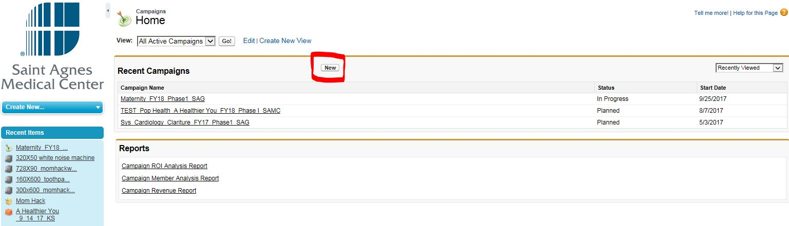

1. Enter Campaign Name using our naming conventions ([Naming Conventions](https://evariant.box.com/s/3tcrdl63d9ibq6wtfpj4psyp1gb7q8g2) can be found in BOX under Job Aids/Campaign Building Job Aids)

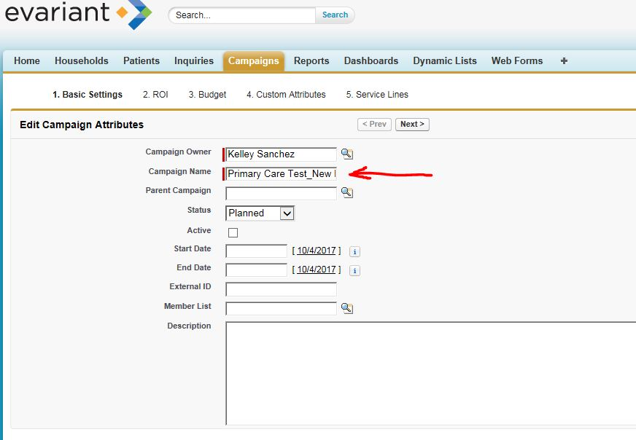

1. Select "In Progress" for status; mark the "Active" checkbox; Select start and end dates for your campaign; Add a brief description of your campaign then click on "Next"

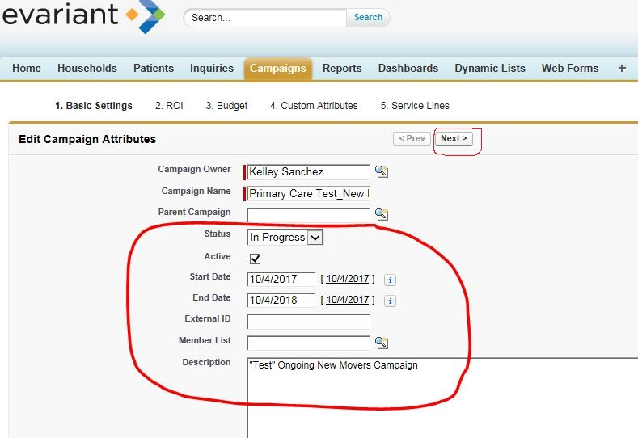

1. Enter the attribution start and end dates are appropriate for the service line that the campaign is running in (e.g., Bariatrics is typically 18 mos.); then click "Next"
   1. Expected revenue and/or responses are not required to set up your campaign, but you will need at least one of these entered by the campaign's end if you want to see ROI. PLEASE NOTE: Even though the field says "expected revenue" it should be viewed as expected Contribution Margin.

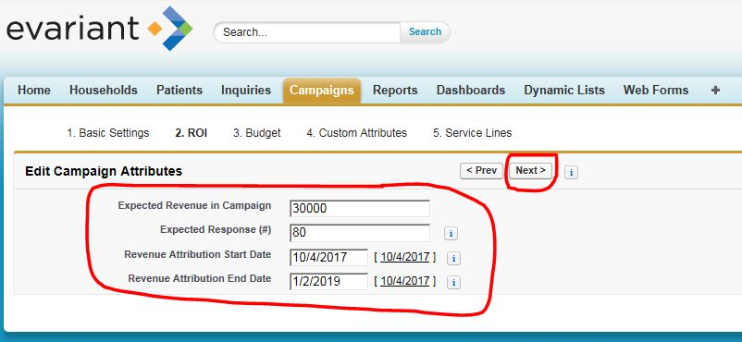

1. Budgeted cost is highly recommended (Note: budgeted cost does not have to be entered at set-up, but will need to be filled-in at campaign close.)

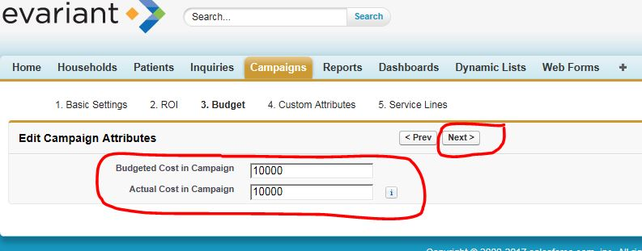

1. Enter campaign "Type," i.e., Service Line, Sub Service Line, Brand, Fundraising, Event, etc. and Program Initiative, i.e., Volume Growth, Brand Awareness, etc. Then click on "Next."

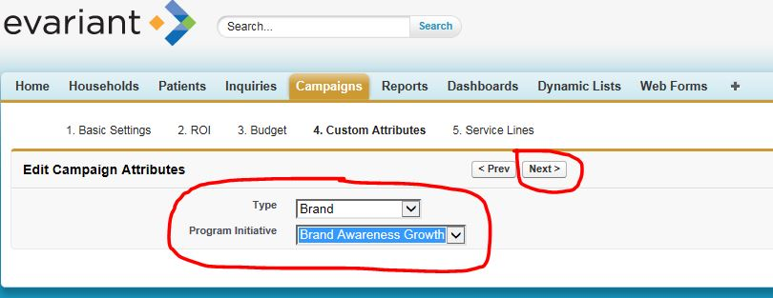

1. Select a primary service line (look up). NOTE: Primary Service Line is needed to calculate ROI. Add secondary service line, if applicable (Secondary Service Line does not impact ROI).

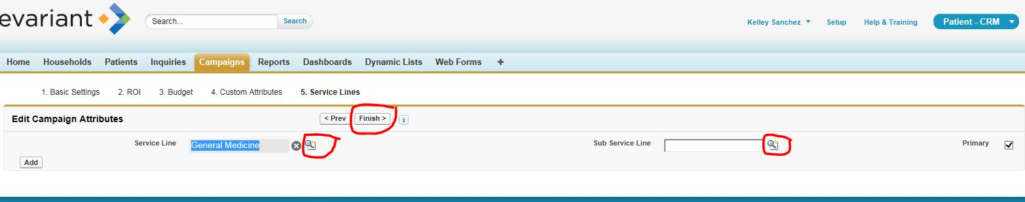

**When you go back to the home page, you will now see your newly created campaign in your Recent Items**

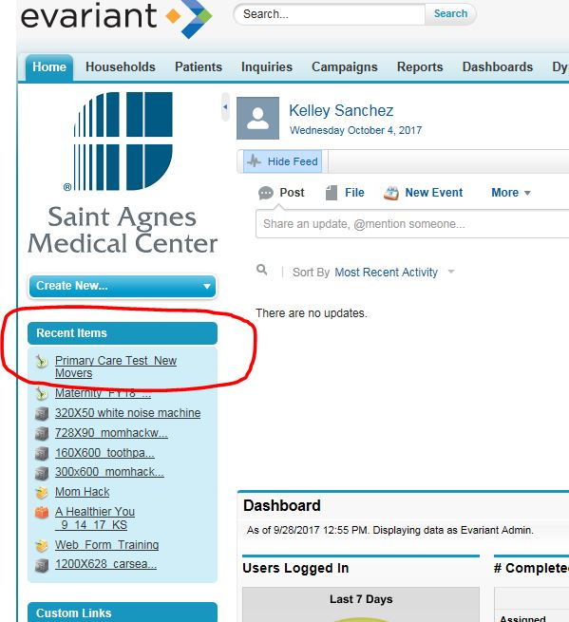

# Chapter 5: Creating Marketing Asset(s)

1. From the Home Page, click on the Plus Sign 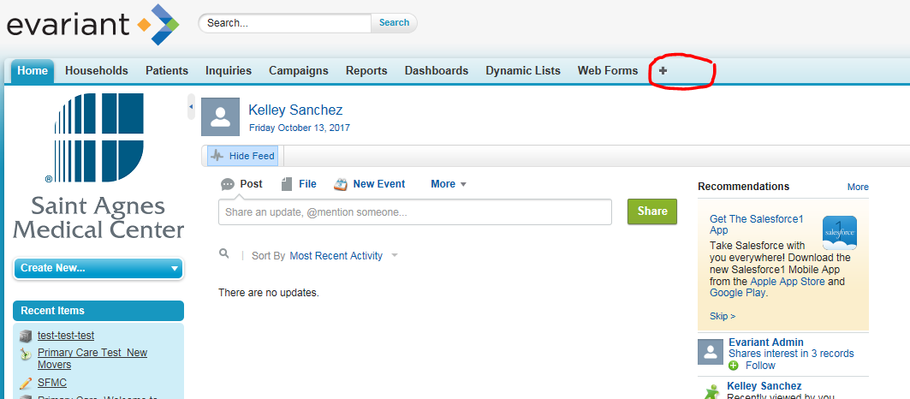
2. Then click on Marketing Assets

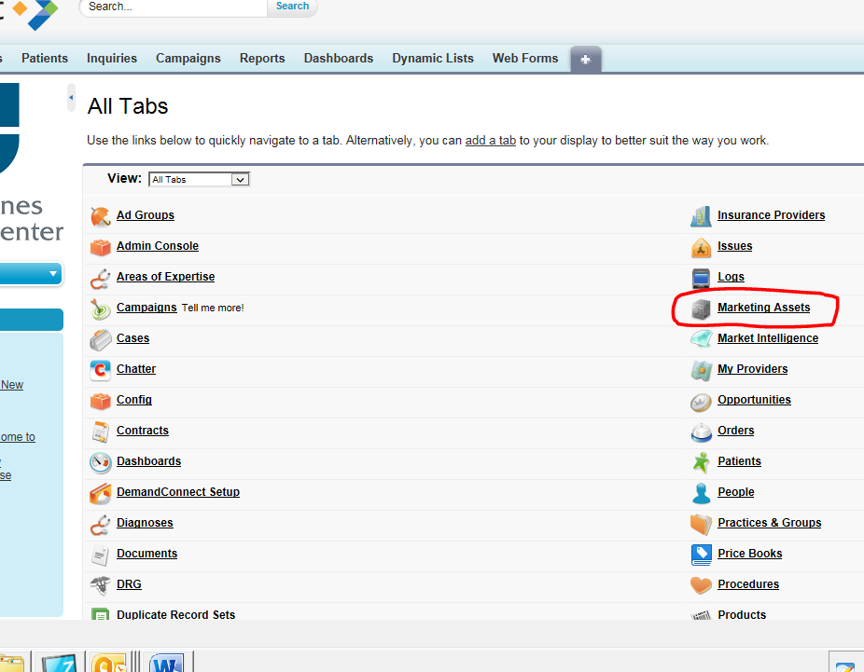

1. Click on New

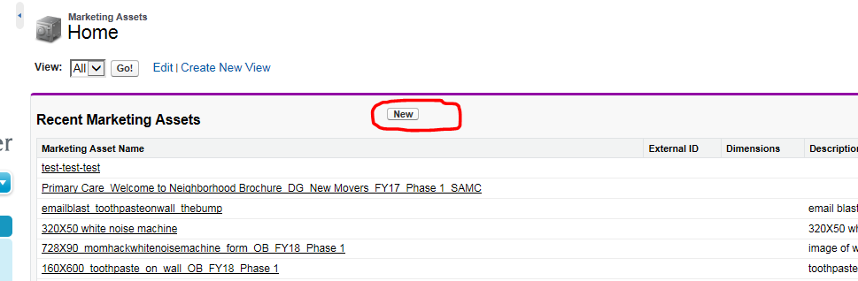

1. Name your asset according to the Naming Conventions (*Campaign Platform Nomenclature* found on BOX) and provide a description, if desired. Then click Save.

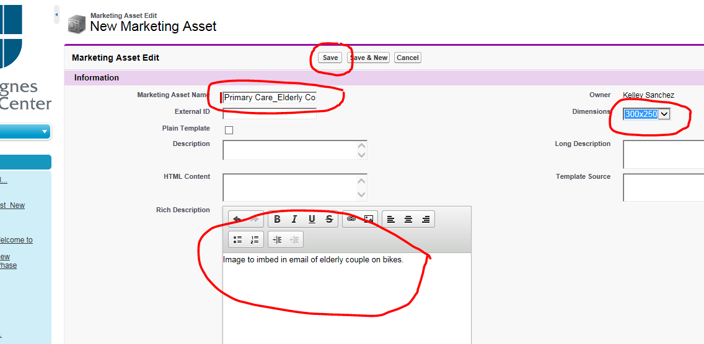

**NOTE:** Once the Marketing Asset is saved, from the Marketing Asset Record screen, you can then add your campaign tactics.

# Chapter 6: Creating the First Campaign Tactic in a New Campaign

**NOTE:** use the following process for the first tactic in your new campaign. For subsequent tactics, follow the instructions outlined in STEP C.)

5. Click on New Campaign Tactic:

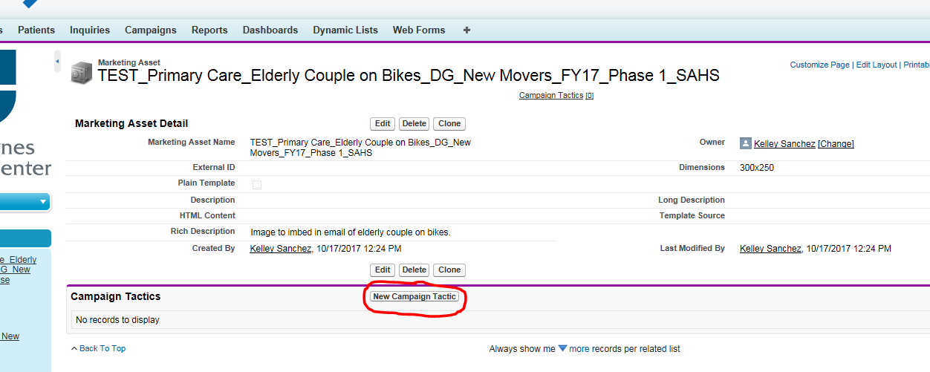

6. Select a Campaign Tactic Record Type from the drop-down menu and click on Continue

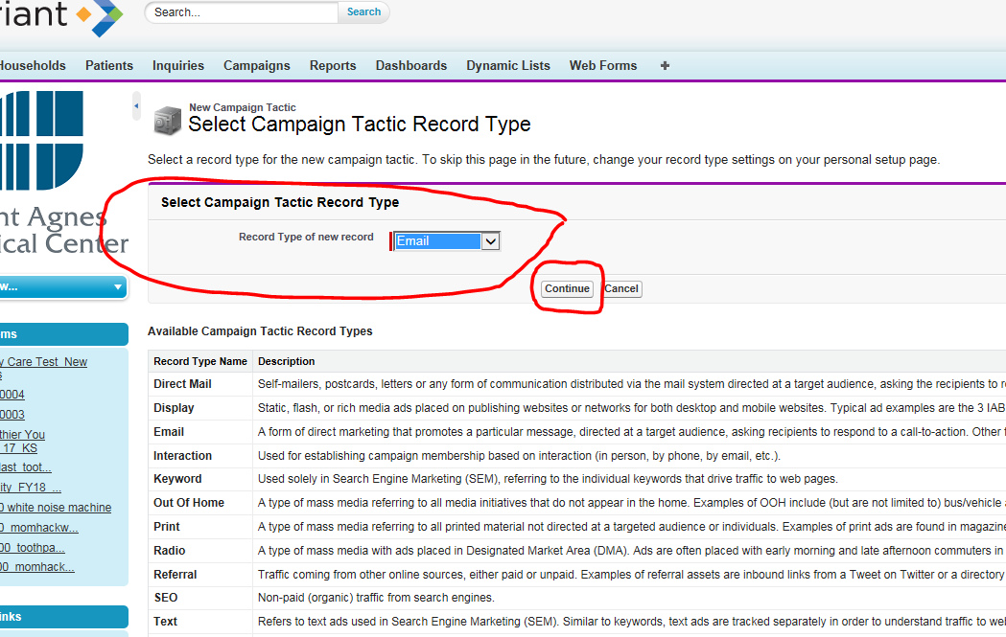

* 1. Use the look up to choose the Campaign and the Vendor.
  2. Add the destination URL (the URL to the landing page/webform)
  3. Click Save

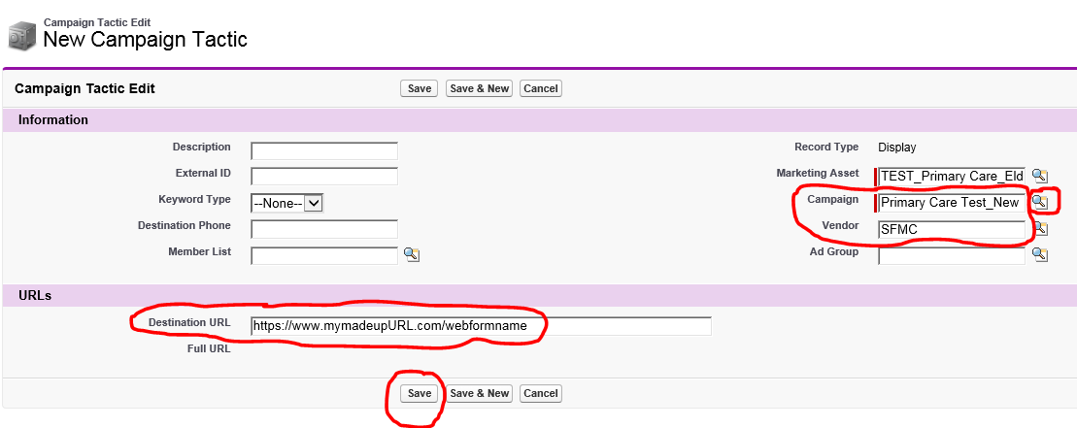

NOTES:

* Call Center is the generic asset for all Call Center tactics.
* Web Site Direct is the generic asset used as a catch-all asset for submits not generated by other response tactics.
  + Every web form needs its own unique web site direct tactic.
* Add only assets that have a unique tracking URL or phone line.
* If you have 30 or more tactics, use the Support Ticket process to upload your list of campaign tactics and/or campaign tactic members. See the [Lead Management](https://app.box.com/folder/37410431613) folder in BOX for appropriate templates.
  1. Click on your campaign name to continue adding campaign tactics:

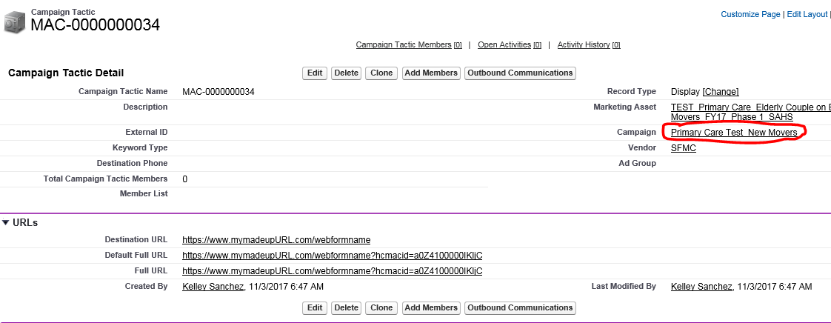

* + 1. Click on Communication Tactics

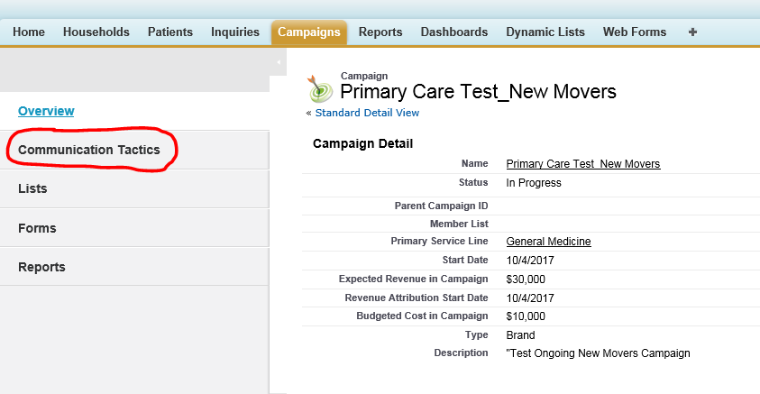

6.Click on New Marketing Asset

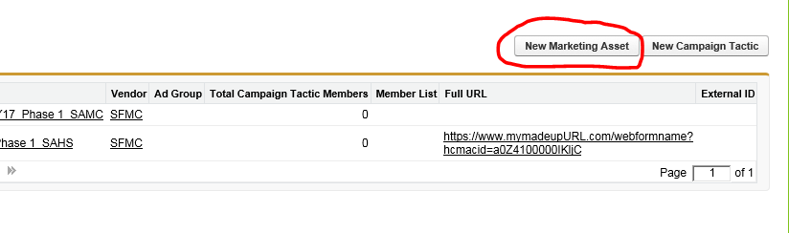

# Chapter 7: Adding Additional Campaign Tactics to Existing Campaigns

1. From the Campaigns tab, click on the link for your Campaign. (Note: if your campaign isn't visible, click on the Go! Button next to All Active Campaigns)

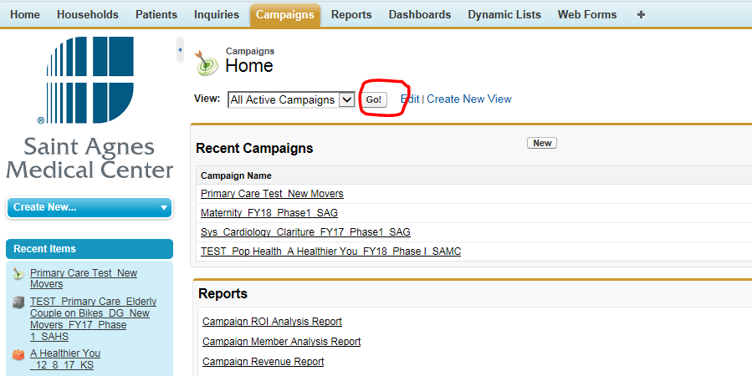

1. Click on Communication Tactics

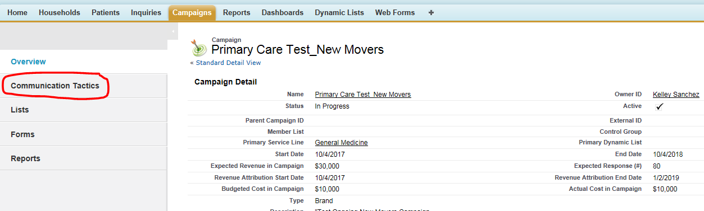

1. Before you click on New Campaign Tactic, be sure you have the assets you need to support it. (If so, skip to #6.) In this case, we want to add a direct mail postcard, so we will first click on New Marketing Asset to create the postcard:

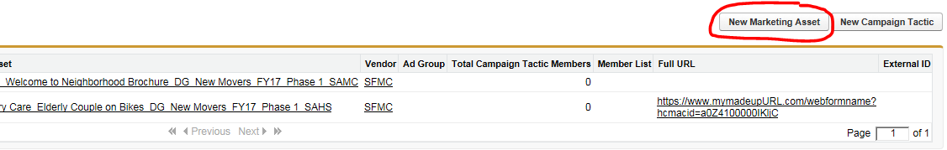

1. Name your asset according to the Naming Conventions (*Campaign Platform Nomenclature* found on BOX) and provide a description, if desired. Then click Save.
2. Click back into your Campaign from your Recent Items menu

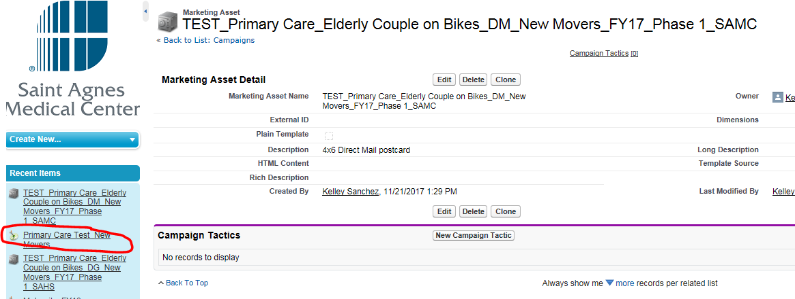

1. Click on Communication Tactics



1. Click on New Campaign Tactic

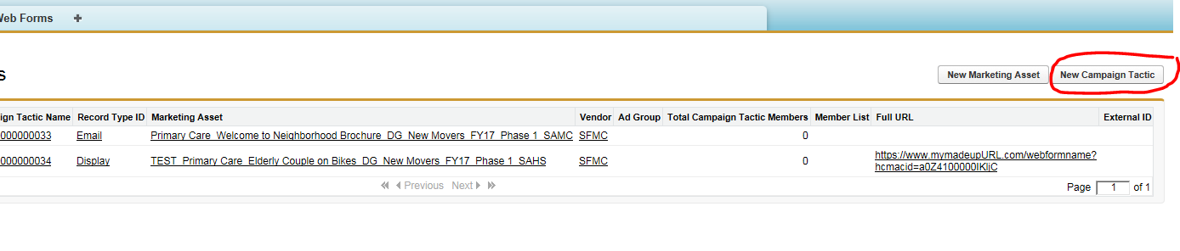

1. Choose your Record Type from the pull-down menu and then click on Next

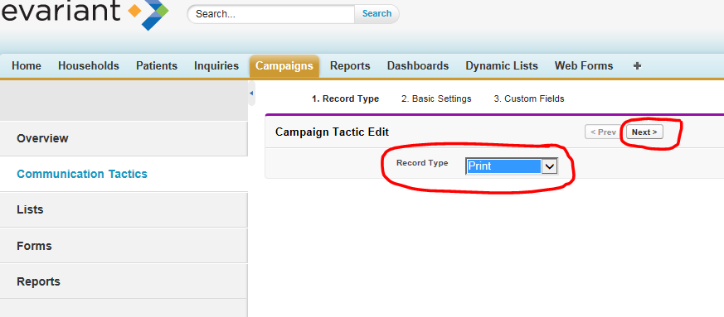

1. Use the Look Up button to select the Marketing Asset and Vendor and the click on Next. Include a description, if desired. *(If you do not see your vendor in the look up, open up a new tab in CRM, go to the plus sign, then click on vendor and create a vendor on-the-fly.)*

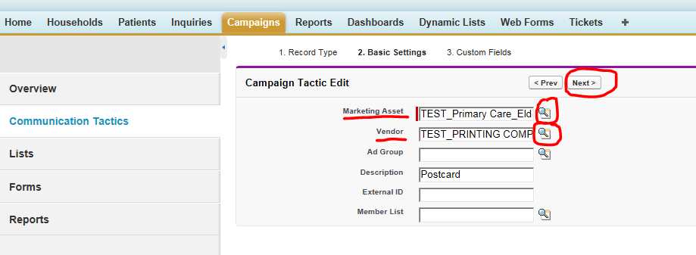

1. Click on Finish

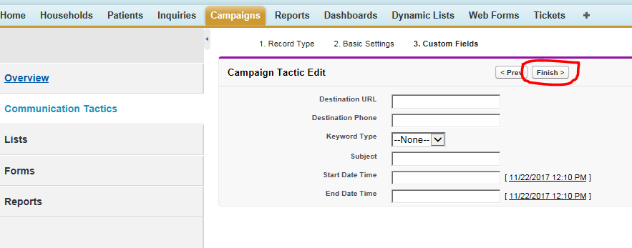

1. From this point, you can continue adding Tactics (if required) using the steps outlined in STEP C.

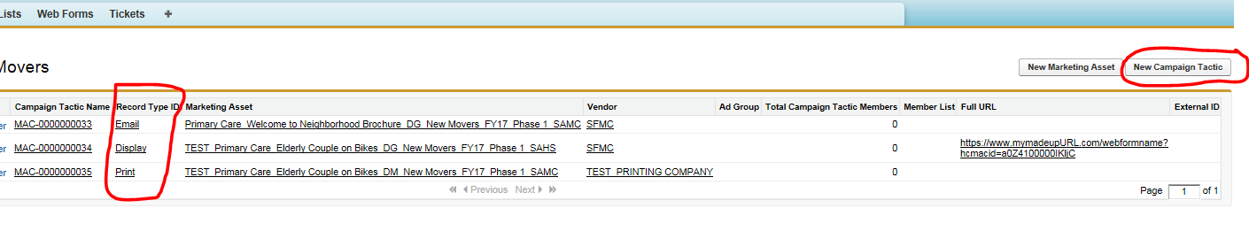

# Chapter 8: Creating Web Forms in CRM

1. In the main navigation bar of CRM, click on the + sign to access Web Forms.
2. Click Web Forms.



1. Click New so the web form page appears.  
   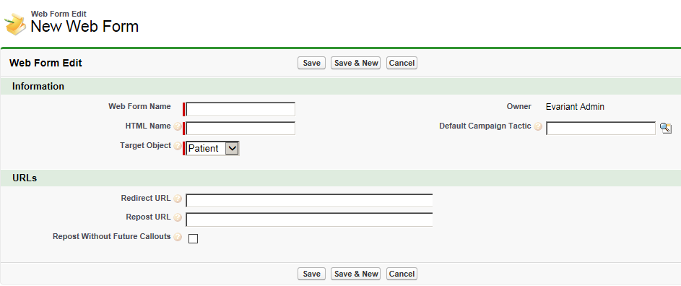
2. In the Information section, type the Web Form Name and HTML name in the appropriate boxes. The HTML name should match the web form name and must not contain any spaces.
3. Click the dropdown arrow in the Target Object field and select three desired target object, likely patients.
4. In the Default Campaign Tactic field, type the campaign tactic ID, which starts with MAC.
5. Add any additional fields other than the standards ones to the web form.   
   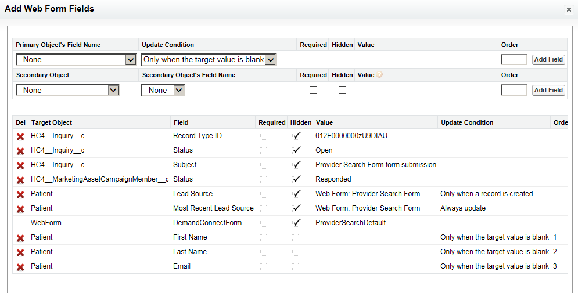
6. Click save.
7. Open a new Microsoft Word document. This is where you are going to paste the web form code. Be sure to include the web form name. This will help when you are transferring the values into your Formstack field.
8. In the statistics section, click Generate HTML  
   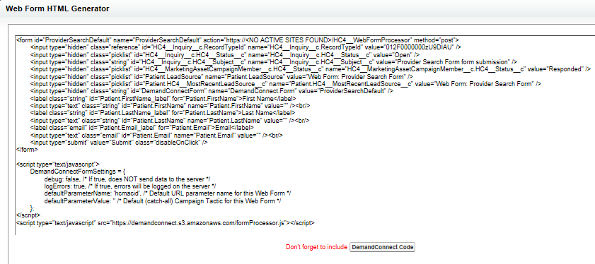

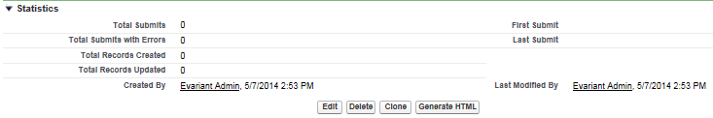

1. When in the Generate HTML popup, click on Demand Connect Code. Click the Select Script dropdown arrow and choose DemandConnect.
2. Click Generate Code. Then copy and paste this into your word document.

When you’re creating your form, if you plan to use this form to trigger a journey, you will want to set up a field for Inquiry Type. This is done by creating a new web form field for a Secondary Object >> Inquiry Type with the Secondary Object’s Field Name set to Inquiry Type.

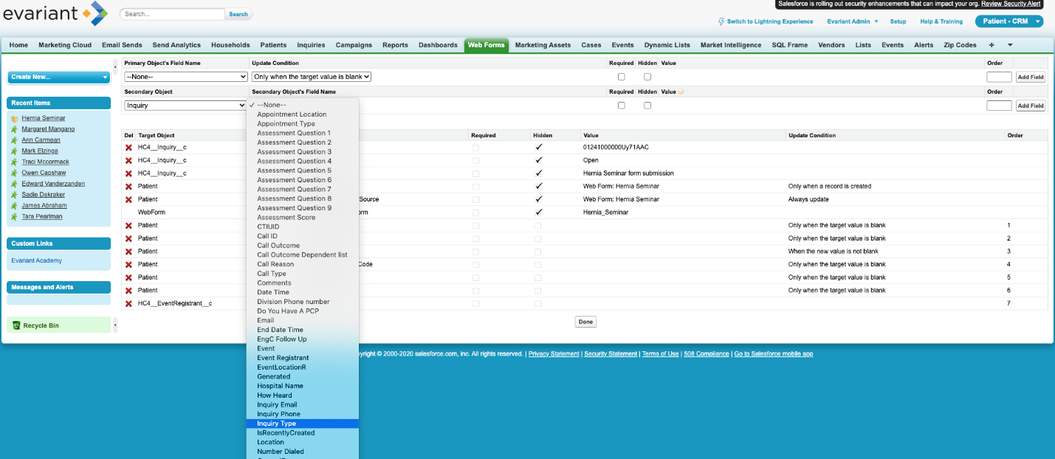

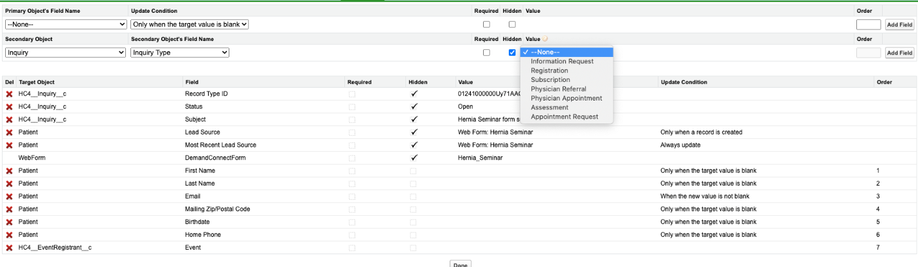

Note, when Value populates, you will want to complete it with whatever type of Inquiry this is: Appointment Request, Opt In, Form Completion, etc. This will depend on your specific campaign.

# Chapter 9: Forms in Formstack

**Create a New Form**

To begin creating a form, click the “Create” button on the Forms tab. This will always appear at the top right of the Forms tab. There is also the option to import a form from a form URL or HTML.    
  
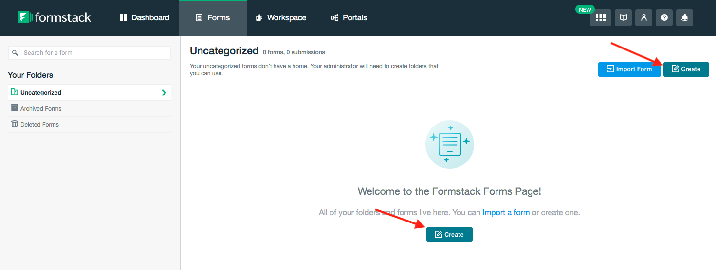

When selecting the Create New Form, you will then have the option to add the Form Name, URL, and Language. The form URL will automatically populate with the form name. If the form URL is already taken, you will be prompted to use another URL. At any point you can click ‘Start with blank form instead’ at the bottom of the window to go directly into the Builder.

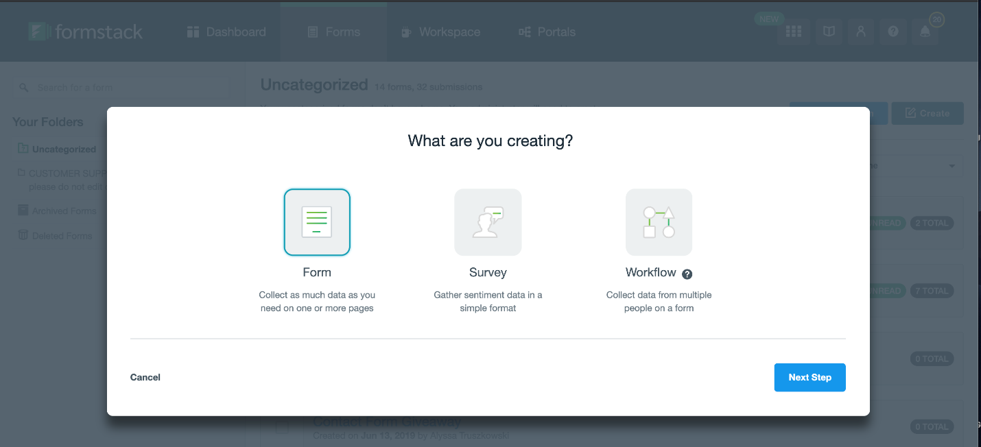

**Build/Add Fields**

Drag a field from the Form Fields menu on the left of the form builder to add the fields you want to your form.



When you click on a field, you’ll see a window slide out from the left where you have options to edit the field you’re on. This is where you can edit language, add logic, etc.

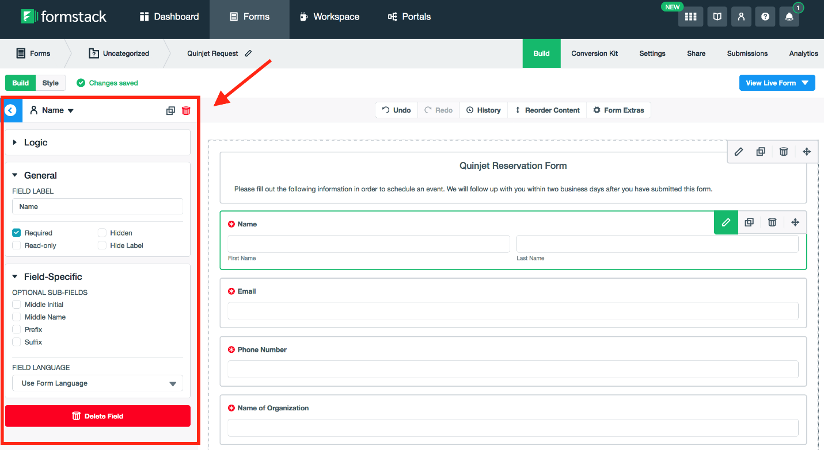

**Form Settings**

Click on “Style” next to Build to adjust the colors and branding of your form.

Click the Settings tab to set the name of a form, the language, the theme, emails & redirects, 3rd party integrations, and plugins. You may also enable security features and add user access to the form.

**Share/Use Your Form**

Click the Share tab to find the embed code needed to place the form on your website.

When choosing, make sure you choose the option for Nojquery.

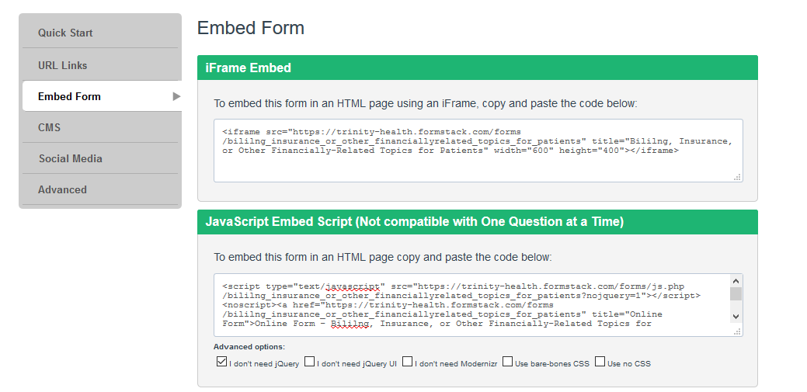

Copy the code and paste it into the source code of your web page. Removing the <div> for “Powered by Formstack:

*<script type=”text/javascript” src=”https://trinity-health.formstack.com/forms/js.php/bililng_insurance_or_other_financiallyrelated_topics_for_patients?nojquery=1”></script><noscript><a href=”https://trinity-health.formstack.com/forms/bililng_insurance_or_other_financiallyrelated_topics_for_patients” title=”Online Form”>Online Form – Bililng, Insurance, or Other Financially-Related Topics for Patients</a></noscript>~~<div style=”text-align:right; font-size:x-small;”><a href=”http://www.formstack.com?utm_source=jsembed&utm_medium=product&utm_campaign=product+branding&fa=h,3932414” title=”Powered by Formstack”>Powered by Formstack</a></div><~~script type=’text/javascript’>if (typeof $ == ‘undefined’ && jQuery){ $ = jQuery}</script>*

Be sure to remove the <div> that pulls in the “Powered by Formstack” text.

Add the following to ensure you have no issues with users submitting the form if not completed correctly before hitting submit the first time:

*<script type="text/javascript" src="https://samc.formstack.com/forms/js.php/preregistration_form?nojquery=1"></script> <noscript><a href="https://samc.formstack.com/forms/preregistration_form" title="Online Form">Online Form - Pre-Registration Form</a></noscript>* ***<script> $('input.fsSubmitButton').on('click',function(){ $(this).removeClass('disabled'); }); </script>***

# Chapter 10: Syncing Forms to CRM

To sync forms with CRM, you will need to need to make sure that the form fields are named as following field labels ensuring that Hide Label is clicked:  
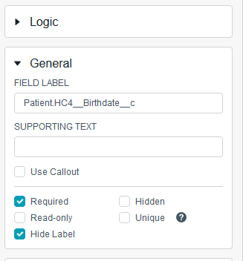

* First Name: Patient.FirstName
* Last Name: Patient.LastName
* Email: Patient.Email
* Birthdate: Patient.HC4__Birthdate__c
* Phone: Patient.Phone
* Zip: Patient.PostalCode
* Then you’ll need to add Hidden fields for the following with the fields being populated by information you’ll pull directly from CRM after creating the web form:  
  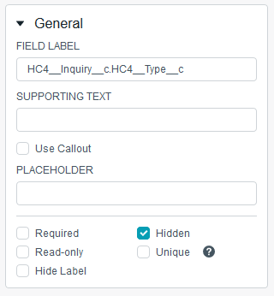
  + HC4__Inquiry__c.HC4__Type__c
  + DemandConnect.Form
  + demandconnect0_value
  + HC4__Inquiry__c.RecordTypeId
  + HC4__Inquiry__c.HC4__Status__c >> This value will always be “Open”
  + HC4__Inquiry__c.HC4__Subject__c
  + Patient.LeadSource
  + Patient.HC4__MostRecentLeadSource__c
  + demandconnect0_field >> This value will always be “HC4__ExternalID__c
  + demandconnect0_time  
    Set Default Value to “Now”

Navigate to settings and then Emails & Actions. Expand Advanced Settings to add a Webhook. Name the Webhook “Evariant CRM Webhook” and add a link to allow the form to send to CRM adjusting to read with your HM’s URL:

* Webhook URL: <https://holycrosshealthsilverspring.secure.force.com/HC4__WebFormProcessor>
* Click “Post with sub-field names”
* Make sure “Post using field names (default) is chosen under “Post Data Field Key”
* Set Content Type to “URL-Encoded Form Data”

Note: You will likely want to add Description Area fields above each of the fields listed above with a patient-friendly naming convention, as you’ll hide the field name for the CRM integration.

Another important step that must be taken is adding .js to your site to allow for the integration. Create a file in Notepad and name it “evariantformstack.js”. Copy and paste the following into your file. Then upload to your assets JS file.

*$('[formstack-form-url]').each(function(){*

*var fsDiv = $(this);*

*function getFSUrlParameter(name) {*

*name = name.replace(/[\[]/, '\\[').replace(/[\]]/, '\\]');*

*var regex = new RegExp('[\\?&]' + name + '=([^&#]*)');*

*var results = regex.exec(location.search);*

*return results === null ? '' : decodeURIComponent(results[1].replace(/\+/g, ' '));*

*};*

*function updateFSQueryStringParameter(uri, key, value) {*

*var re = new RegExp("([?&])" + key + "=.*?(&|$)", "i");*

*var separator = uri.indexOf('?') !== -1 ? "&" : "?";*

*if (uri.match(re)) {*

*return uri.replace(re, '$1' + key + "=" + value + '$2');*

*} else {*

*return uri + separator + key + "=" + value;*

*}*

*}*

*var fsFormURL = fsDiv.attr('formstack-form-url');*

*// Check to see if formstack-form-url attribute exists*

*if (fsFormURL) {*

*// Get the hcmacid URL Parameter*

*var hcmacidUrlParameter = getFSUrlParameter('hcmacid');*

*// Get the utm_campaign URL Parameter*

*var utmCampaignUrlParameter = getFSUrlParameter('utm_campaign');*

*// Get the utm_source URL Parameter*

*var utmSourceUrlParameter = getFSUrlParameter('utm_source');*

*// Get the utm_medium URL Parameter*

*var utmMediumUrlParameter = getFSUrlParameter('utm_medium');*

*// Get the utm_content URL Parameter*

*var utmContentUrlParameter = getFSUrlParameter('utm_content');*

*// Check to see if hcmacid is specified in Query String*

*// Convert the hcmacid query string parameter to demandconnect0_value for the FormStack Form*

*if (hcmacidUrlParameter) {*

*fsFormURL = updateFSQueryStringParameter(fsFormURL, 'demandconnect0_value', hcmacidUrlParameter);*

*}*

*// Check to see if utm_campaign is specified in Query String*

*if (utmCampaignUrlParameter) {*

*fsFormURL = updateFSQueryStringParameter(fsFormURL, 'utm_campaign', utmCampaignUrlParameter);*

*}*

*// Check to see if utm_source is specified in Query String*

*if (utmSourceUrlParameter) {*

*fsFormURL = updateFSQueryStringParameter(fsFormURL, 'utm_source', utmSourceUrlParameter);*

*}*

*// Check to see if utm_medium is specified in Query String*

*if (utmMediumUrlParameter) {*

*fsFormURL = updateFSQueryStringParameter(fsFormURL, 'utm_medium', utmMediumUrlParameter);*

*}*

*// Check to see if utm_content is specified in Query String*

*if (utmContentUrlParameter) {*

*fsFormURL = updateFSQueryStringParameter(fsFormURL, 'utm_content', utmContentUrlParameter);*

*}*

*document.write('<script type="text/javascript" src="' + fsFormURL + '"></script>');*

*}*

*});*

Note to embed the form on your page, you have to use the following code instead of the embed code supplied by the Formstack system replacing the highlighted with your Formstack URL and then the name of your form respectively:

*<div formstack-form-url="https://samc.formstack.com/forms/js.php/ortho_joint_download_guide?nojquery=1">*

*<script src="/assets/js/evariantformstack.js"></script>*

*</div>*

When you’re done creating and editing the fields in your Formstack account, it should look something like this:

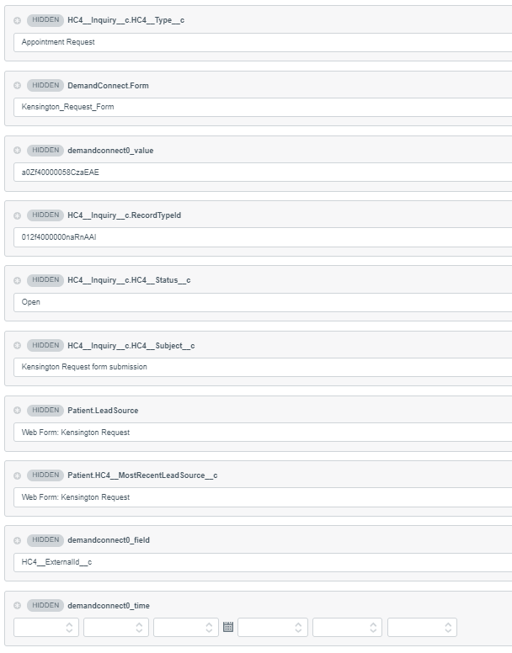

# Chapter 11: Campaign Landing Page Set Up

This guide will take you through the process of setting up a Campaign Landing Page using three different templates. All you have to do is fill in the various content fields and select a template. The result will be a pre-styled page with a set layout.

**Creating a Campaign Page**

1. Navigate to the the _Pages folder in the “Campaigns” subsite folder:
2. Click on “File”, then “New”, then select “Folder” under the “Model” section. Name the folder appropriately then click “Create”: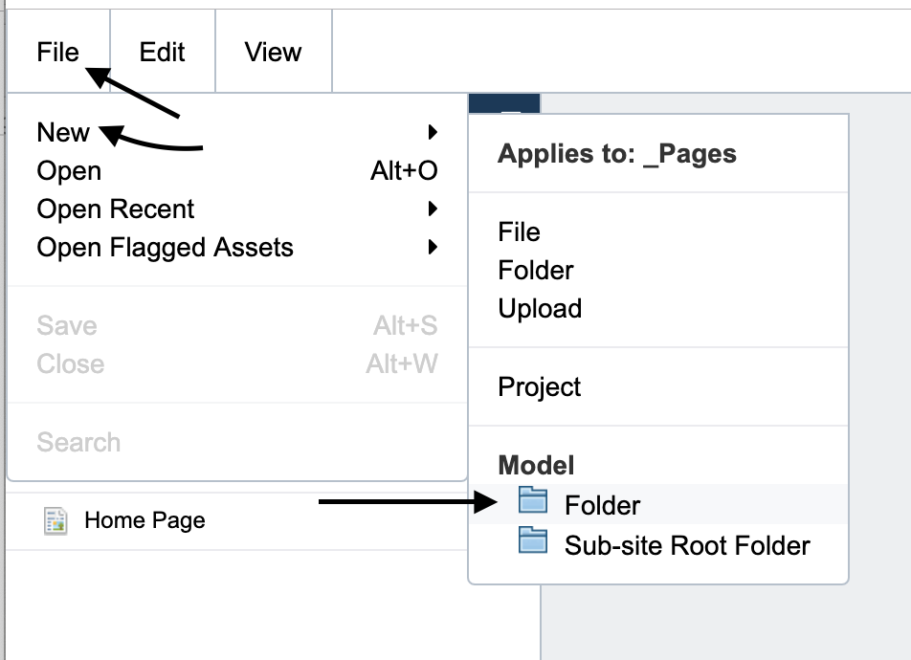
3. Double click on your new folder to open it up. Double click on _Folder Configuration to open that file.
4. On the “Navigation” tab, select “No Navigation” from the dropdown of both Left and Right Rail Navigations. Any page created in this folder will now have no left or right navigations: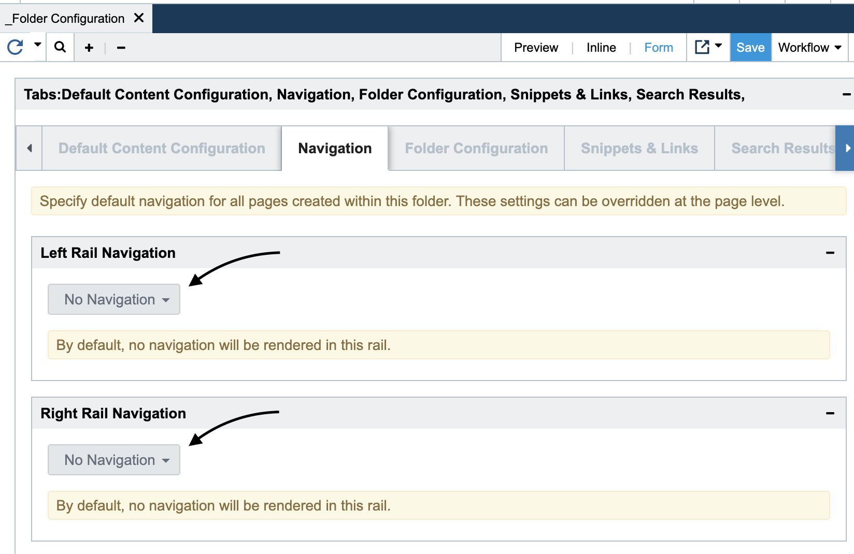
5. On the “Folder Configuration” tab, check the “Hide H1 On new pages created within this folder” box. From now on, any page created in this folder will hide the H1 title from the page: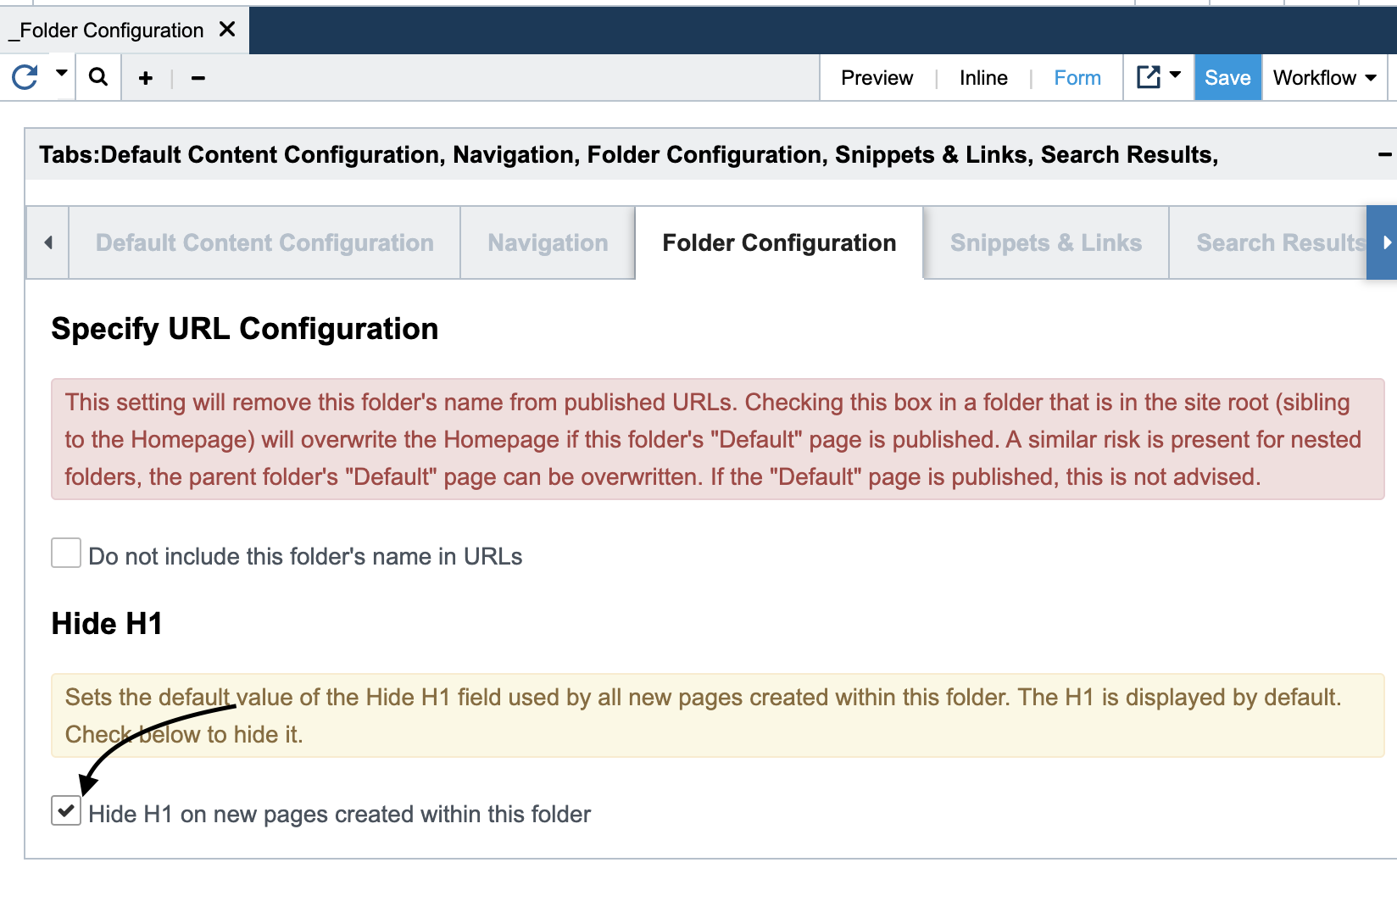
6. Click on “Save”. Then, from the “Workflow” dropdown, click on “RePublish”: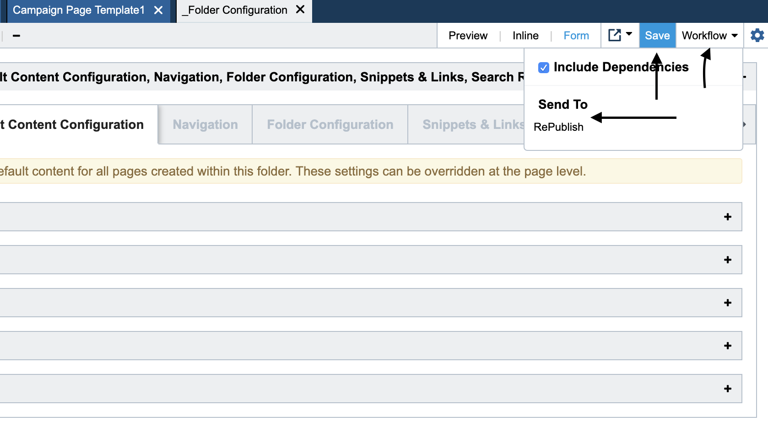
7. Now it’s time to create a new page. While in the folder you wish to create a page on, click on “File”, then “New”. Confirm that the “Applies to…” heading at the top is applying to your folder name, then click on “Content Page” under the “Model” section. Name page accordingly and click “Create”:

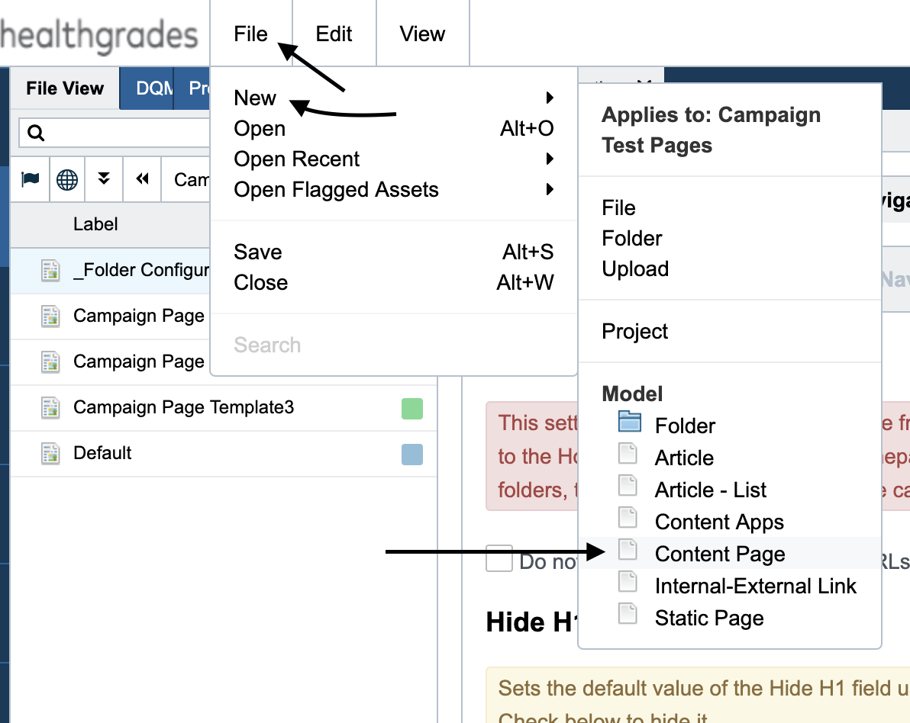

1. Expand the view window by clicking on the “+” at the top. In the “Main Content” tab, select “Campaign Landing Page” from the Content Type dropdown, then select either “Template 1”, “Template 2”, or “Template 3” from the “Layout” dropdown, depending on which layout you desire (see next step for reference):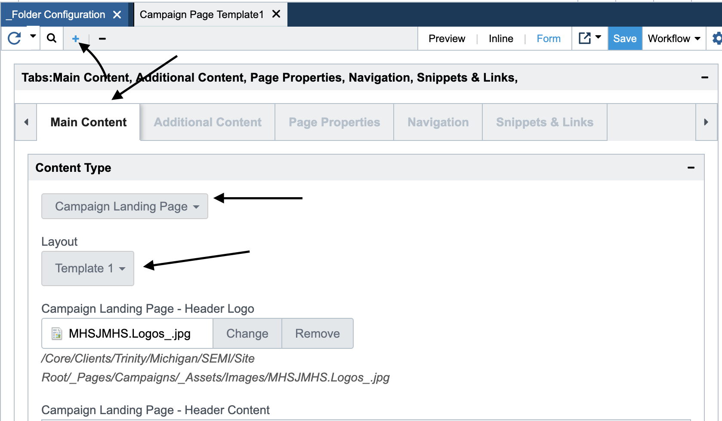

There are 3 Campaign Landing Page layouts that you can choose from. Examples of what each one will look like can be found here:

Template 1: <https://perficient.invisionapp.com/share/6PRYOHKQFUA#/screens/376349009>  
Template 2: <https://perficient.invisionapp.com/share/6PRYOHKQFUA#/screens/385540717>  
Template 3: <https://perficient.invisionapp.com/share/6PRYOHKQFUA#/screens/376347866>

1. Once you’ve decided on a template. It is now time to start populating the various fields with content. This will be handled in more detail in the next section.

**Adding Content to Campaign Landing Page Fields**

1. There are several fields to populate with content on your new Campaign Landing Page. These fields will correspond to various sections of a template’s layout. Since Template 3 uses every field in its layout, we will use it as a reference below, and then get into each field in more detail. All fields begin with “Campaign Landing Page -”, so we will leave that prefix out of the field names below:
   1. Header Section includes the fields “Header Logo”, “Header Content”, “Banner Image”, and “Banner Content”: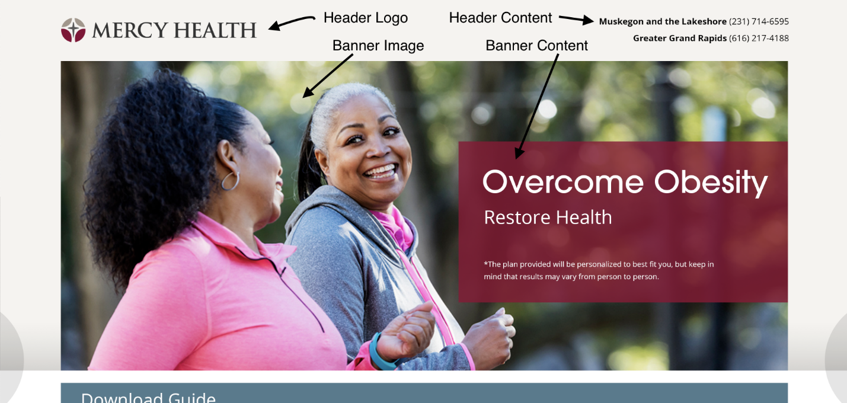
   2. The Body Section includes the fields “Form1 - Title”, “Form1”, “Main Content”, “Content Image”, “Secondary Content”, “CTA Image”, “CTA Text”, “CTA Link Text”, (“CTA Link” is a hidden field), “Three Steps”: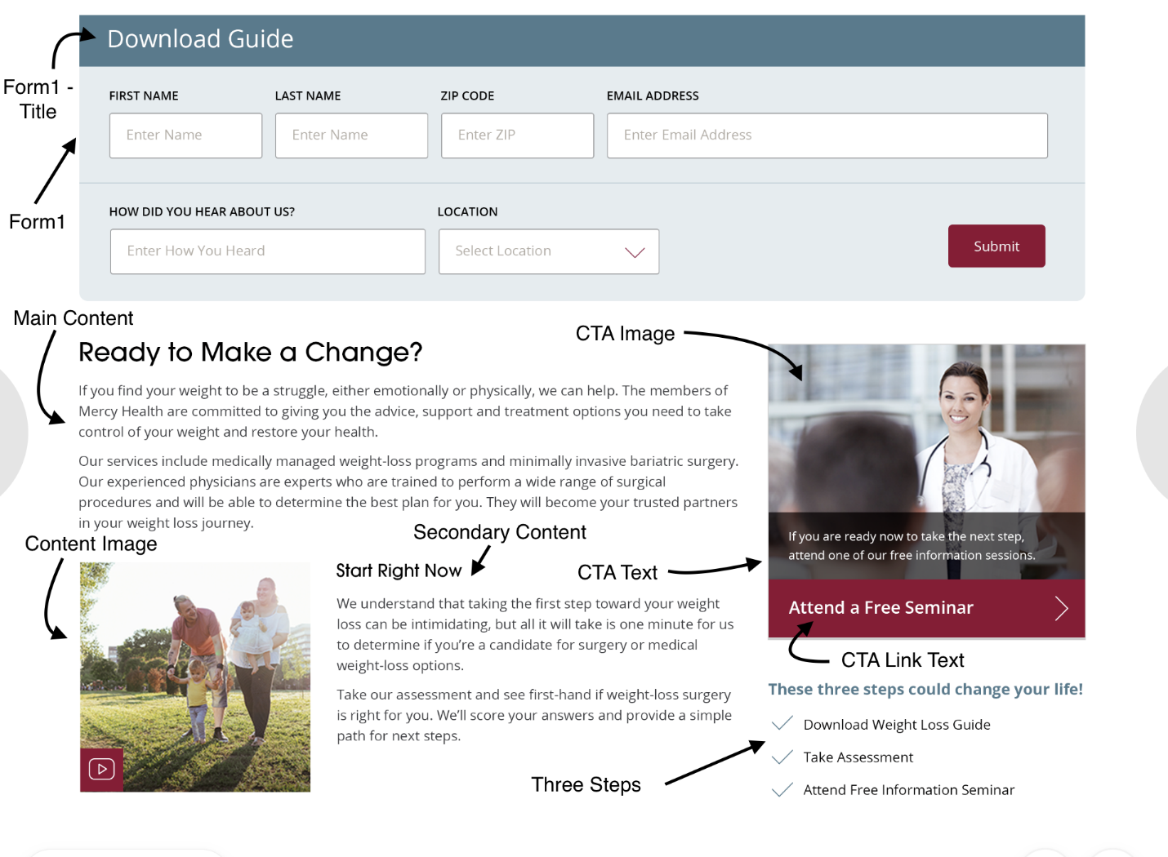
2. Now we’ll look at each field in more detail and offer possible code snippet examples where needed.
   1. Header Logo - This is a Link field. Click on “Select” or “Change” to open up a navigation window. Navigate to the internal asset image of your choice. This will display on the top left of the header.
   2. Header Content - This is a WYSIWYG field. This will typically be used for phone numbers. However, you are free to put anything here. This will display on the top right of the header. As an example, click on the Source Code button (<>) and input the following code example as a template to get the effect shown in the header example above:

*<p><strong>Muskegon and the Lakeshore</strong> (231) 714-6595</p>*

*<p><strong>Greater Grand Rapids</strong> (616) 217-4188</p>*

* 1. Banner Image - This is a Link field. Click on “Select” or “Change” to open up a navigation window. Navigate to the internal asset image of your choice. This will be the large image under the header.
  2. Banner Content - This is a WYSIWYG field. You may put any text here. This will display over the top of the Banner image. For best results, you may wish to use the following code example as a template:

*<h1>Overcome Obesity</h1>*

*<h3>Restore Health</h3>*

*<p>*The plan provided will be personalized to best fit you, but keep in mind that results may vary from person to person.</p>*

If you wish to include a button/link in this section, you can use the following code example:

*<p><a href="URL or internal path here" class="button button--outlined button--light">Apply Now!</a></p>*

* 1. Form1 - Title - This is a Text field. This will be the heading for your form. You can type anything here, ie. “Download Guide”
  2. Form1 - This is a WYSIWYG field. Click on the Source Code button (<>), and paste in your FormStack embed code. Example would be:

*<p>*

*<script type="text/javascript" src="https://Michigan-Digital.formstack.com/forms/js.php/logger"></script>*

*</p>*

*<noscript><a href="https://Michigan-Digital.formstack.com/forms/logger" title="Online Form">Online Form - Logger</a></noscript>*

* 1. Main Content - This is a WYSIWYG field. You may put any text here. This will be the main body of content on the page.
  2. Secondary Content - This is a WYSIWYG field. You may put any text here. This will be your page’s smaller bit of content and will usually be contained in a styled box with the Content Image.
  3. Content Image - This is a Link field. Click on “Select” or “Change” to open up a navigation window. Navigate to the internal asset image of your choice. This will usually display under the Main Content and may be contained in a box with Secondary Content.
  4. CTA Image - This is a Link field. Click on “Select” or “Change” to open up a navigation window. Navigate to the internal asset image of your choice. This only appears on Template 3. It is the image contained in a CTA box to the right of the main content.
  5. CTA Text - This is a Text field. You may type any text here. This only appears on Template 3. It is contained in a CTA box to the right of the main content and appears in a transparent, black box over the CTA image.
  6. CTA Link Text - This is a Text field. You may put any text here, ie. “Attend a Free Seminar”. This only appears on Template 3. It is contained in a CTA box to the right of the main content and appears in a transparent, black box over the CTA image.
  7. CTA Link - This is a Text field. You must put either an external url or an internal path here, ie. “<https://www.mercyhealth.com/campaigns/lakeshore-laser/specials>”, or “/about-us/community-benefit/”. This only appears on Template 3. It is contained in a CTA box to the right of the main content and appears in a maroon box under the CTA image.
  8. Three Steps - This is a WYSIWYG field. You may put any text here, however the styling for this is rigid. So, for best results, you will want to use the following code example as a template:

*<div class="three-steps">*

*<h4>These three steps could change your life!</h4>*

*<ul class="three-steps-list">*

*<li>Download Weight Loss Guide</li>*

*<li>Take Assessment</li>*

*<li>Attend Free Information Seminar</li>*

*</ul>*

*</div>*

You may add or delete steps by simply adding or deleting a list item ie. <li>Content</li>.

Make sure you mark your page as Hide from Site Search, “no index, no follow” and “exclude from site map” on the Page Properties tab.

# Chapter 12: Placing Pixels

To place Facebook, Invoca or other pixels on your campaign landing pages, navigate to the Snippets & Links tab. Make sure you choose “Inherit from Folder Configuration and Add Additional Snippets.” Paste your snippets in the appropriate place “Head Close”, “Body Open”, or “Body Close”.

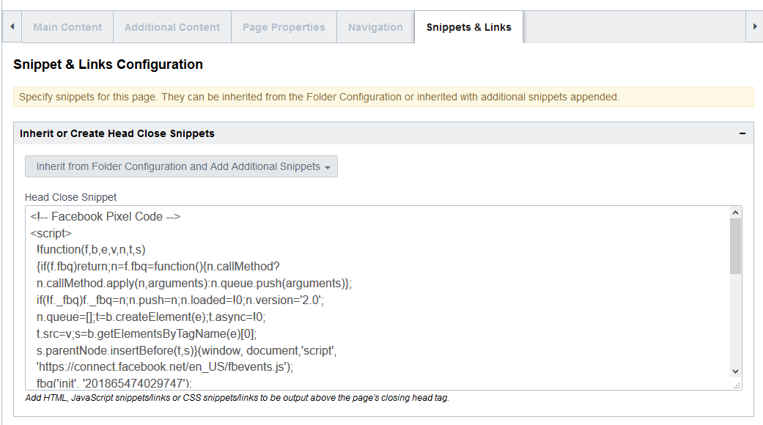



# APPENDIX

# Appendix A: Trinity Health Campaign Team

The following resources are available from the System Office:

|  |  |
| --- | --- |
| **Role** | **Role Summary/Contact** |
| **Sumedha Mandpe** | Assists with overall campaigns and vendor discussions Email: Sumedha.mandpe@trinity-health.org |
| **Karen Cameron** | Assists with campaign set up, tactics, content, etc. Email: karen.cameron@trinity-health.org |
| **Cassi Snyder** | Assists with building campaign landing pages Email: Cassandra.snyder@trinity-health.org |

# Appendix B: Template Links

Links provided below can be used as building references for all three templates:

* Template 1:
  + CMS: <https://cms.crownpeak.net/IH_Trinity/V3/#/content;folder=355510;asset=355513;viewAsset=355513;view=Edit;tab=352135-355513-355511-343964-287188-355533>
  + URL: <https://live-semi-trinity-ih.cphostaccess.com/campaigns/campaign-test-pages/campaign-page-template1>
* Template 2:
  + CMS: <https://cms.crownpeak.net/IH_Trinity/V3/#/content;folder=355510;asset=355533;viewAsset=355533;view=Edit;tab=352135-355513-355511-343964-287188-355533>
  + URL: <https://live-semi-trinity-ih.cphostaccess.com/campaigns/campaign-test-pages/campaign-page-template2>
* Template 3:
  + CMS: <https://cms.crownpeak.net/IH_Trinity/V3/#/content;folder=355510;asset=356132;viewAsset=356132;view=Edit;tab=352135-355513-355511-343964-287188-355533-356132>
  + URL: <https://live-semi-trinity-ih.cphostaccess.com/campaigns/campaign-test-pages/campaign-page-template3>

Following are links to download the PSDs and supporting assets. In additional to the material below, the [Enterprise Style Guide and Component Library](https://perficientdigital.box.com/s/f7frjxv93qqddd9dfpgngz3xwegbd5lm) provides comprehensive direction for the standards established.

**NATIVE PSDs**

[Download the PSDs](https://perficientdigital.box.com/s/3wn1b9sciyb4si1kwktthg90375ayomb)

**ASSETS**

[Photos](https://perficientdigital.box.com/s/a8fuetolxjb68imukmb6qlcesegm19ho)| The templates use commercial stock photography (watermarked). FPO images have been provided for any photos that have not been licensed. Any commercial stock photos used for implementation that were not provided by the RHM or pulled from RHM collateral will need to be licensed.

[Fonts](https://perficientdigital.box.com/s/48k5lba71dj4x8nmqlt89o0htfzea40u)| The primary typeface for St. Joe’s is Avant Garde.  
[Supporting Art](https://perficientdigital.box.com/s/dsg493j9zfbejor9pavle1s1nw26un82)| Linked vectors, icons, and other remaining files associated with the composites

**COMPS FOR VIEWING**

Visit the Comp Sites: [Original Content](https://perficient.invisionapp.com/share/6PRYOHKQFUA) | [Alternative Content](https://perficient.invisionapp.com/share/DCU3G6EVTBN)  
[Download PNGs](https://perficientdigital.box.com/s/xfw1edwkmfrjtkrhqb9122p0kx0ssviz)  
[Download PDFs](https://perficientdigital.box.com/s/o3sz7imvon4a5qgtrig5ofp7bd65phrl)

# Appendix C: Campaign Landing Page Testing Results

* User Testing Results (PPT): <https://perficientdigital.box.com/s/qpn6imcttzrhushvfc8tm8g98wzq8pcu>
* User Testing Results (XLS): <https://perficientdigital.box.com/s/sy1wwe7hzjpt46oieorno4vaoht9dy6r>
* Helio Website Report:   
  <https://my.helio.app/report/01DJZZGV55QVCPMWHPX677MTP9>

# Appendix D: End-to-End Data Flow

# 